NHBCO 2022-2023 Season
Important Dates and other items
ASSOCIATION WEBSITE: nh.nhsbca.org
Twitter Account: @NhbcoHoops

December 5th- $45.00 for a varsity coach- $75 for a signal gender (up to 7 coaches) or $125 School plan (Up to 15 coaches) dues should be paid for by this date. A $5.00 late fee will be charged after Dec. 7.
You can pay your dues online at https://nh.nhsbca.org/nhbco-membership or send a Check made out to NHBCO and mailed to Meghan Averill 36 Cedar Street Newmarket, NH 03857
PLEASE LOOK AT 2ND SHEET TO FILL OUT COACHES INFORMATION

January 27th – Nominations due for all state- Each school can nominate up to four players. Nominees do not have to be seniors; Very important--- Spell names correctly, list position, size and uniform number. Send to your class representative. Send nominees in order of ability. (List your top player first) Example:
Note: You do not have to nominate 4 players, if you only feel you have 2 that are worthy, nominate only 2. If you are 0-7 by Jan. 7th you probably don’t have 4 all state players.
 | No. | Players Name | Positions | Height | Year
1 | 23 | Jeff Holmes | G | 6’3” | 12
2 | 10 | Jimmy Jones | F | 6’4” | 12
3 | 15 | Jessie Jenkins | G | 5”11” | 11
4 | 00 | Cassie Turcotte | C | 6’8” | 10
PLEASE EMAIL YOUR NOMINATIONS TO YOUR DIVISION REP. BY JANUARY 14TH

January 24th - The NHIAA official’s recommendation list is due. You as a coach get to vote for officials who work the tournament. This is an NHIAA initiative but is very important for Basketball coaches to be a part of. This list is sent to the NHIAA. Your Class Rep will be sending you a sheet sometime in December through email that has directions and a list of officials.

February 24 ^{th}- All-Academic qualifiers will be due to your class representative by this date. Helpful Hint---Turn your All-Academic List into your school’s guidance department at the end of quarter 2 which is usually mid-January. This will give them plenty of time to have it ready for you to mail or fax to your representative by March 6th. This date is very important because names need to be sent to the printer.

March 3rd- All State Ballots are due online. Vote ONLINE @ nh.nhsbca.org You need to be a NHBCO dues paying member in order to vote. If you are not a due paying member, your players on your team will have 5pts deducted from their total. The ballots will be sent out by your class representative shortly after nominations have been received. These ballots are used for All-State Teams and Awards and used for divisional All-Star Games. You must also submit your nomination for Mr. or Ms. New Hampshire Basketball and if you are nominating a player for the Jack Ford award. (This year we will honor both a male and female from each division.
March 12 Tentative Date for Senior All-Star Games @ NHTI Times to be announced
March 12th- NHBCO Spring Membership Meeting 9am-10:30am.
- Awards for All State, Coach of the Year, Jack Ford and Mr. Ms New Hampshire Basketball
- Officers: Nomination for President, Vice President, Secretary
- Other Business

Please look at the attached sheet for Membership information.

Dave Chase
NHBCO President

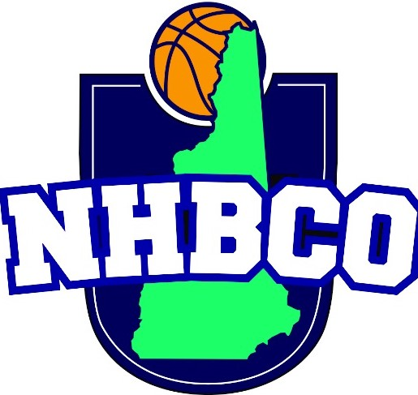

2022-2023 Membership
Varsity Coaches Dues $45.00 before Dec. 5, 2022 $50 after 12/5/22
Single Gender program (Up to 7 coaches) $75 before Dec 5, $90 after
School Package $125=Both Varsity, JV, Freshman coaches (15 coaches) $150 after Dec 5
Assistant Coaches: $20 each
All Checks should be made out to NHBCO
Mail to: Meghan Averill 36 Cedar Street Newmarket, NH 03857

(Mandatory: Fill out Varsity Coaches Information)

School: | Division: | Gender: Boys Girls Both

Name | Position | Email | Cell: | Address
1. | Var Girls
2. | JV Girls
3. | Fr Girls
4. | Var Boys
5. | JV Boys
6. | Fr Boys
7. | Asst
8. | Asst
9. | Asst
10. | Asst
11 | Asst
12 | Asst
13 | Asst
14 | Asst
15 | Asst

